**SQL Portfolio Project**

**"Stack Overflow Post Analysis: A SQL Portfolio Project"**

**New Insights and Questions:**

1. Which users have contributed the most in terms of comments, edits, and votes?

SELECT

user_id,

COUNT(text) AS total_comments

FROM comments

GROUP BY user_id;

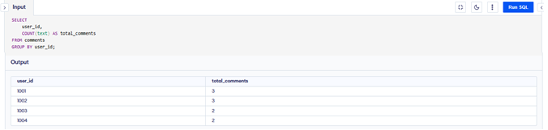

**Analysis of the query:**

This query identifies the users who have contributed the most in terms of comments, by counting the number of comments each user has made. The total_comments column shows the total number of comments for each user.

1. What types of badges are most commonly earned, and which users are the top earners?

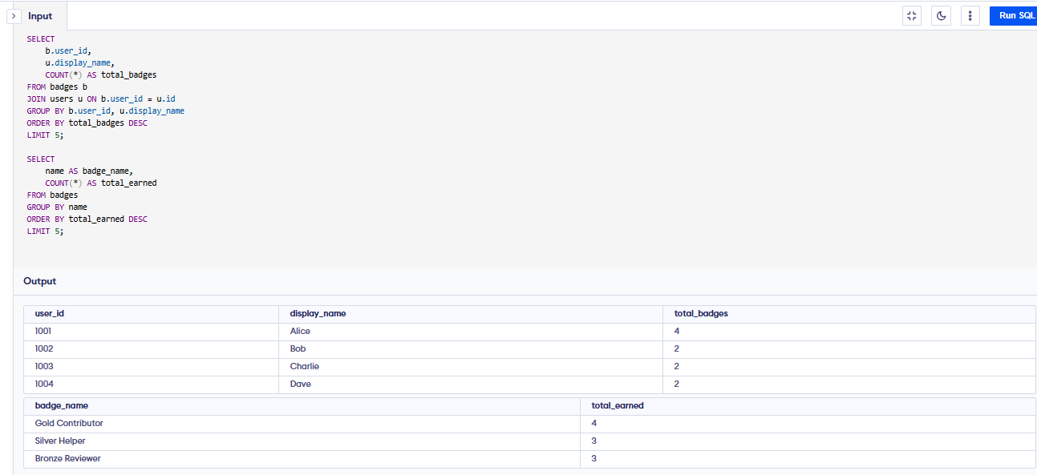

**Analysis of the query:**

Option #1: identifies the top users based on the total number of badges earned, showing the user_id, display_name, and their respective badge counts.

Option #2” highlights the most commonly earned badge types, listing each badge name and the total number of times it has been earned.

1. Which tags are associated with the highest-scoring posts?

There is no direct link between the **tags** and **posts** tables because neither table contains the primary key of the other as a foreign key.

Since there are no common values between them, we cannot use a JOIN to connect them.

Therefore, the query does not match the given dataset correctly.

1. How often are related questions linked, and what does this say about knowledge sharing?

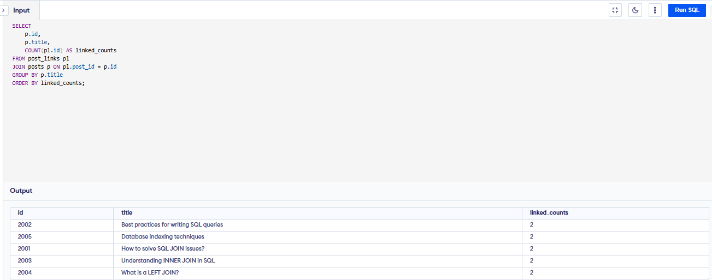

**Analysis of the query:**

This query analyses how frequently posts are linked to related questions by counting the number of related post links for each post. A higher count of links indicates a greater level of knowledge sharing and suggests that posts are often referred to or associated with other relevant content.

**THE END**